2021年8月18日星期三

Please implement an application that compares Forward Rendering with Deferred Rendering. Your implementation should demonstrate the advantages and disadvantages of these two techniques.

I will provide more details on Monday, 19th July.

Deliverables:

1**. YouTube video**

2. Source code & assets

3. Implementation report

Length: 10 pages

Formatting: 1-1.5 spacing, Times 12 point font or equivalent, single column, moderate margins

Abstract: overview of what you’ve done

Background: Summary of technical paper

Implementation details: **tech & demo**

Results/Evaluation: **how fast, how much detail can you handle in real-time? How many resources does it hog-up**

**Improvements / limitations**

**Proper Citation of papers, source code, libraries, text, images and assets used**

The supplemental assignment is due Monday, 30th August.

Furthermore, you will have to online-demonstrate your work on Monday, 6th September. This should include a 10 minute presentation.

Further information ( Monday, 19th July ):

please base your implementation on the following paper:

Deferred adaptive compute shading  
<https://doi.org/10.1145/3231578.3232160>

早起三明

2021年7月28日

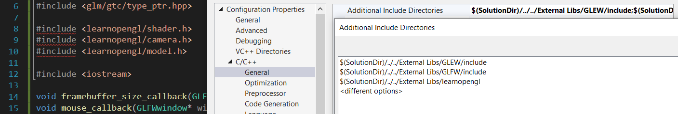

在此明明链接了learnopengl文件夹然而还是有红线，现在删除包含链接，用“”手动添加

删除之后红线数量未有影响。

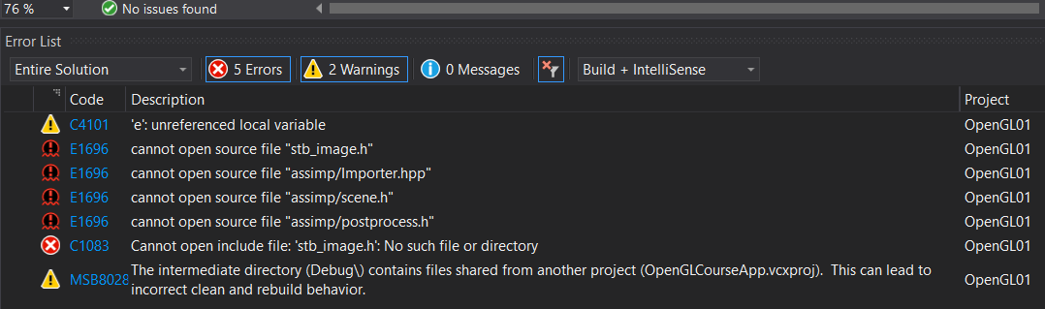

又遇到这个错误，或找到原来的Udemy文件再配置。

**延迟着色法(Deferred Shading)**，**或者说是延迟渲染(Deferred Rendering)**，为了解决上述问题而诞生了，它大幅度地改变了我们渲染物体的方式。这给我们优化拥有大量光源的场景提供了很多的选择，因为它能够在渲染上百甚至上千光源的同时还能够保持能让人接受的帧率。下面这张图片包含了一共1874个点光源，它是使用延迟着色法来完成的，而这对于正向渲染几乎是不可能的(图片来源：Hannes Nevalainen)。

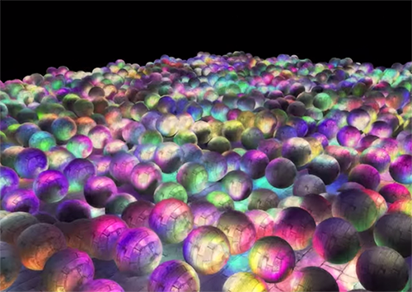

渲染待看视频

[4K Checkerboard in Battlefield 1 and Mass Effect Andromeda - Frostbite (ea.com)](https://www.ea.com/frostbite/news/4k-checkerboard-in-battlefield-1-and-mass-effect-andromeda)

[GDC Vault - Advanced VR Rendering Performance](https://www.gdcvault.com/play/1023134/Advanced-VR-Rendering)

[GDC Vault - Rendering 'Rainbow Six | Siege'](https://www.gdcvault.com/play/1022990/Rendering-Rainbow-Six-Siege)

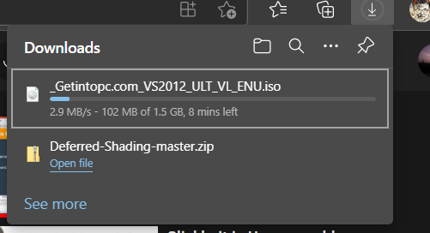

已近下载好了，在此处。

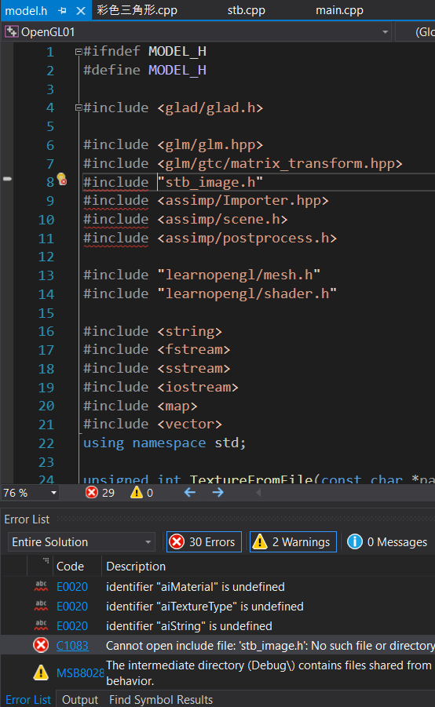

继续之前的27.1来操作，现在还有这些红线需要解决。

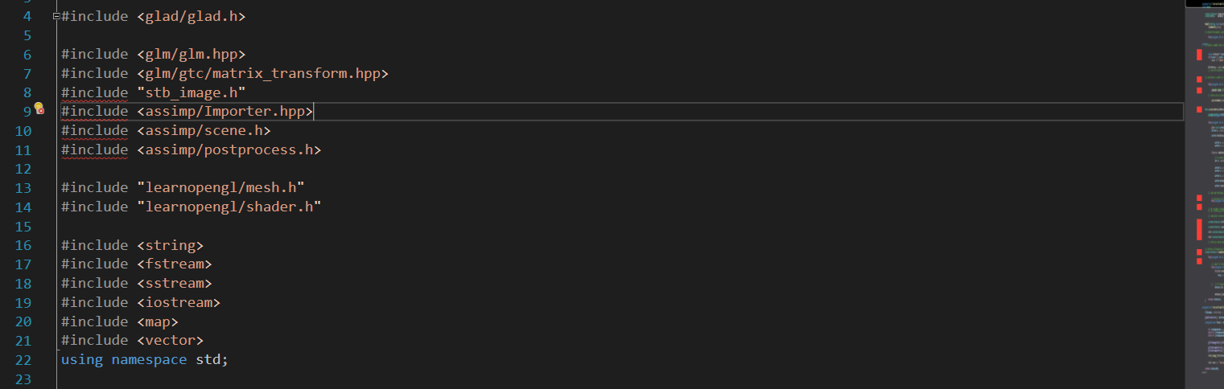

要弄这个。

[C++ OpenGL Tutorial - 17 - CMake/ASSIMP Installation - YouTube](https://www.youtube.com/watch?v=oci7xJEg6sU&t=16s)

试一试这个教程。

[Modern OpenGL 3.0+ [MODEL LOADING] ASSIMP Setup Using CMAKE Windows - YouTube](https://www.youtube.com/watch?v=W_Ey_YPUjMk)

换了一个教程。

不行，还是用前一个教程，因为前者是2020的，后者是2017的。

版本不一样了。

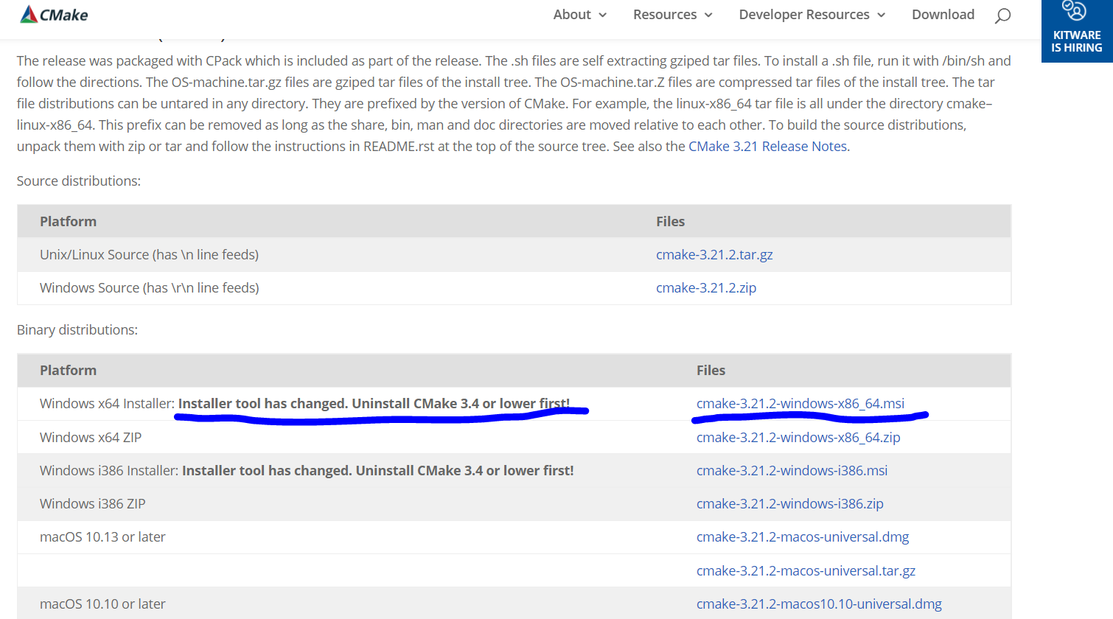

先卸载之前的CMake吧

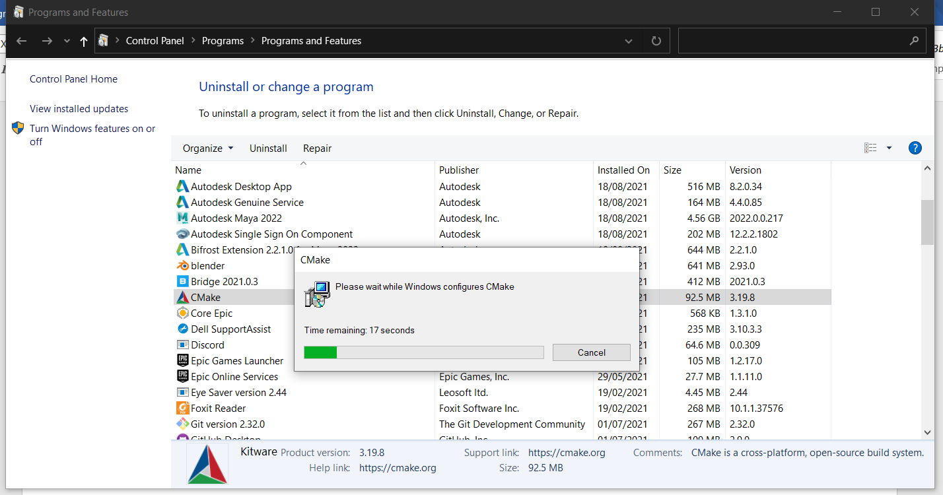

没有Windows64

安装了第一个更新后的。

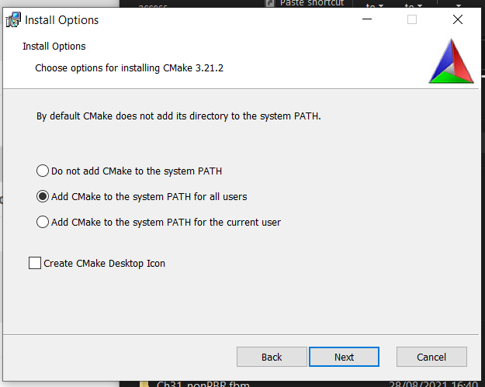

Assimp5.0.1

下载

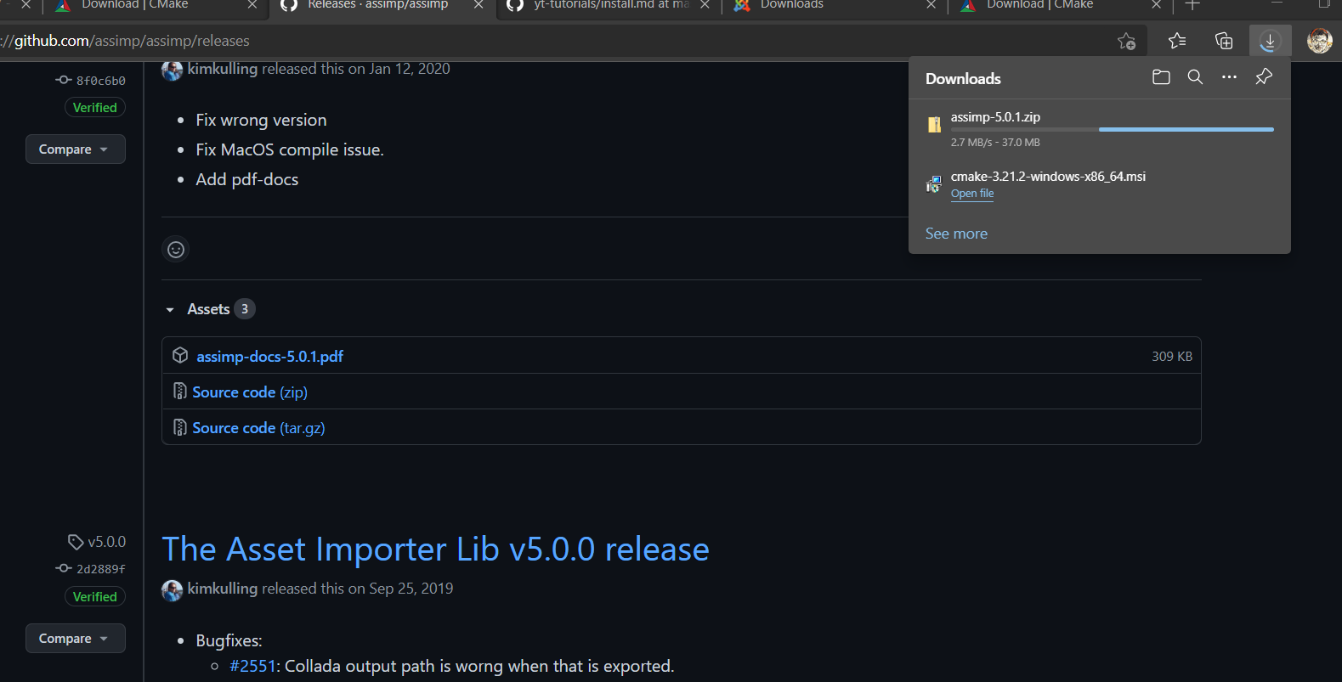

Assimp之前已经下载了。

新名称下载。

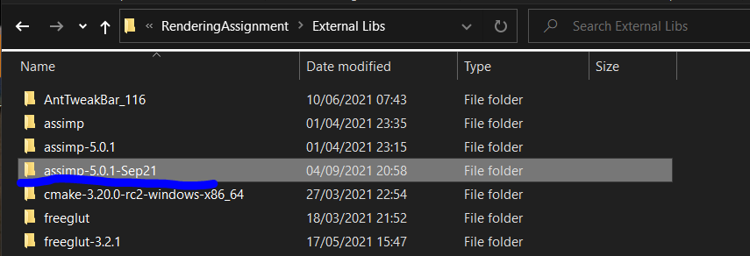

两次点击Configure后，不同于教程，出现了下面的警告，跳过吧。再点击一次Generate。

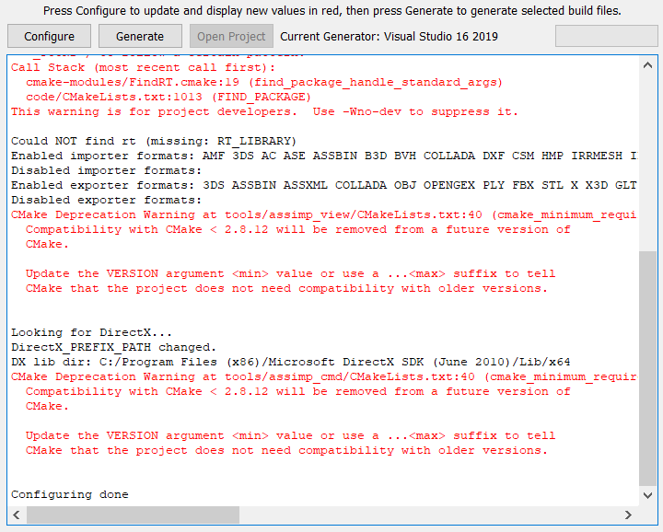

发现刚刚错误的Configurate Generate到了以前的路径文档里面了。

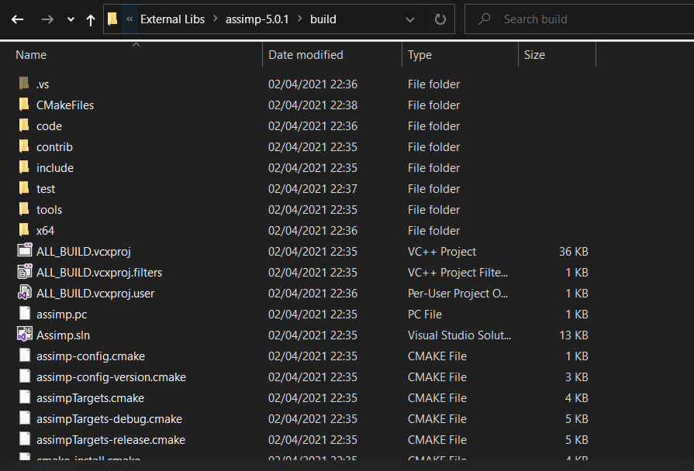

现在又改过来了，还是有警告，跳过。

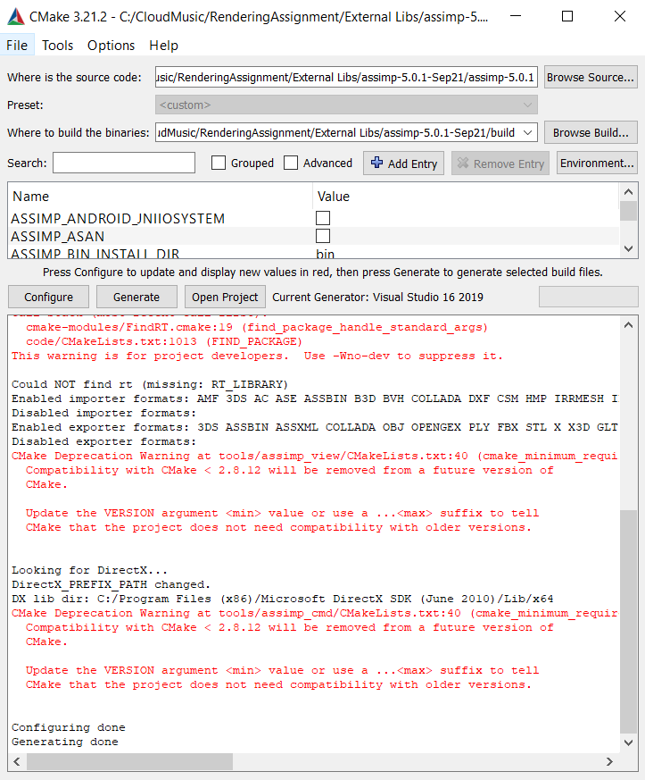

我方9成功，而教程是8成功，其余一样，或无影响。

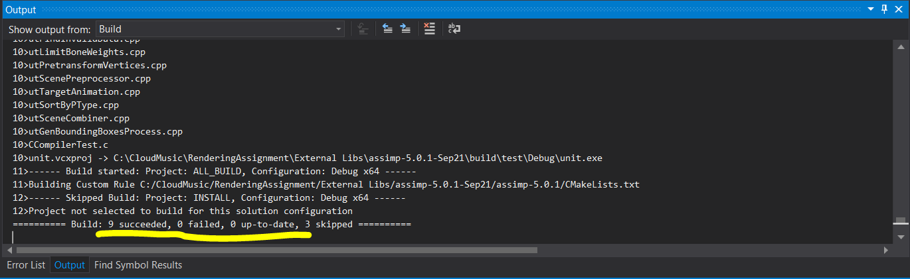

放在了这里

C:\CloudMusic\RenderingAssignment\27.2DeferShading\OpenGLCourseApp\OpenGLCourseApp

与教程不同，我方没有glfw3.dll在此路径。

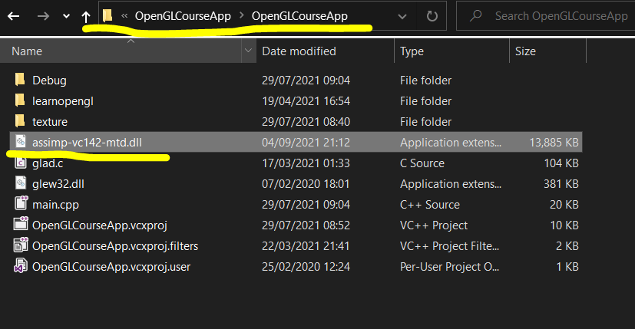

放入此处吧。

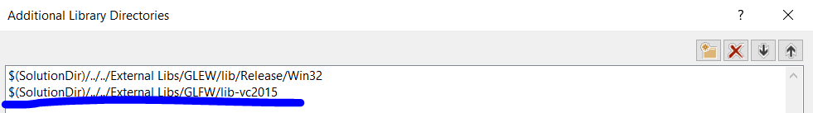

不对，依据教程后面，有更好的方案，之前也创建了新文件夹assimp

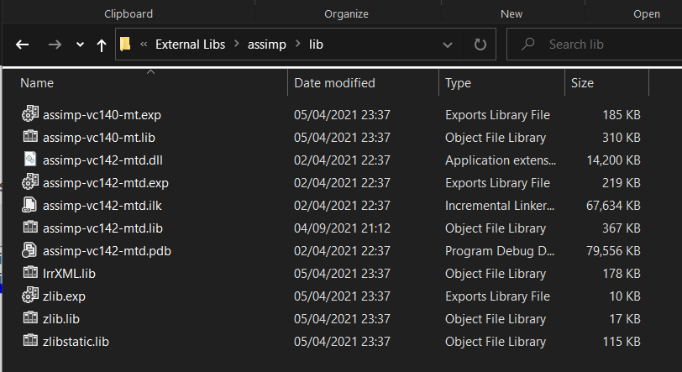

然而现在把新的文件夹改成了assimp-Sep21

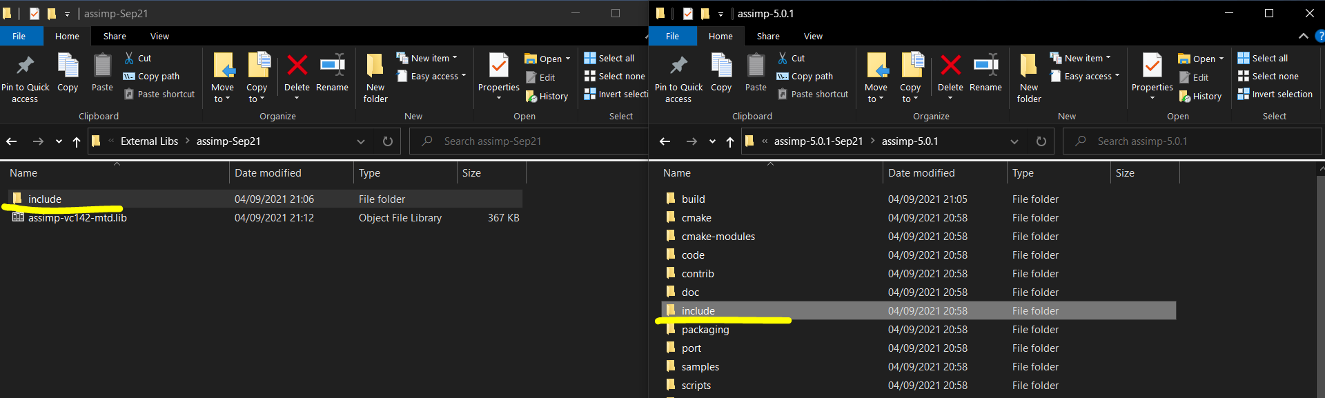

右边复制到了左边。

这里跟教程一样，选择了 Debug x64，而不是之前的all configurations, all platforms

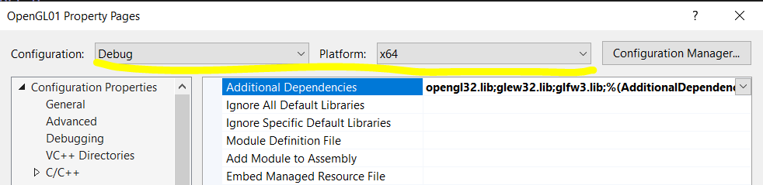

要链接Lib了，8.16教程说在之前里有了教程提到了额外的东西。

我方决定，将所有的路径带上lib，完全粘贴此处，如果有问题，以后再找到视频里所说的另一个教程。

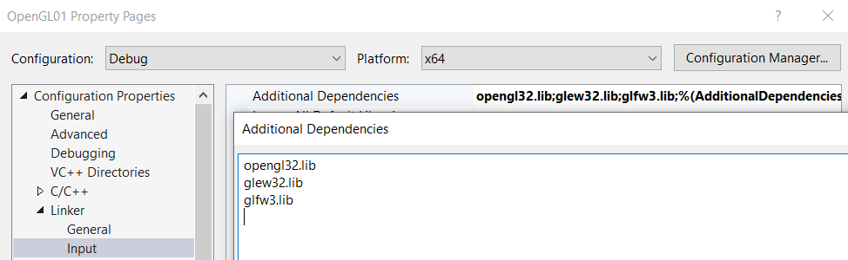

不对，教程中 link 和 source 应该是分开的，和我方不一样，应该去找到之前的“超级重要”三部曲。

为了规范，把原来的lib文件装到了文件夹lib中。

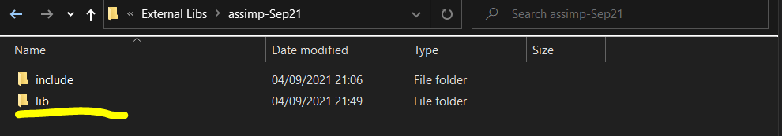

第一步

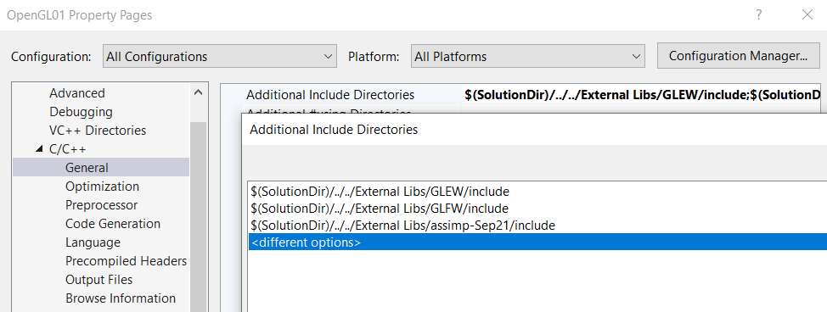

第二步(注意左上方仅一红线，多行红线以消失)

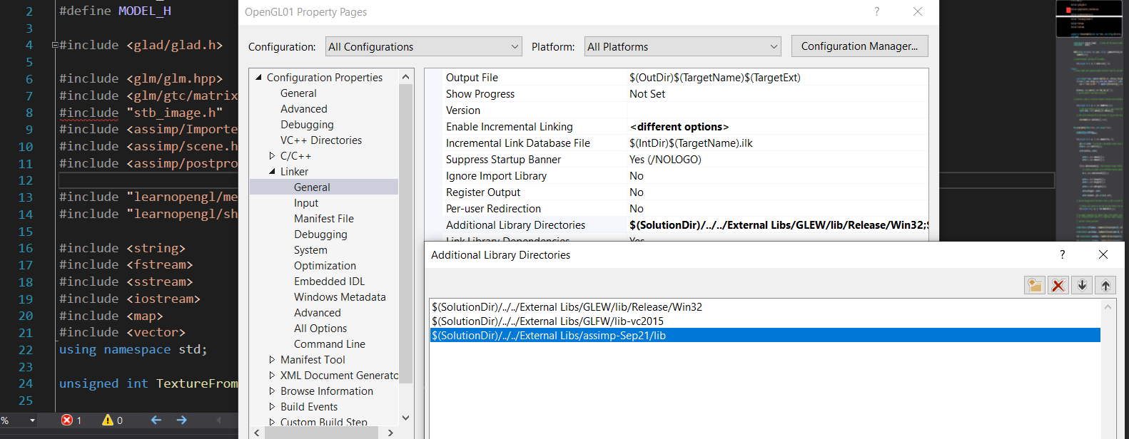

stb_image.h出现了问题。

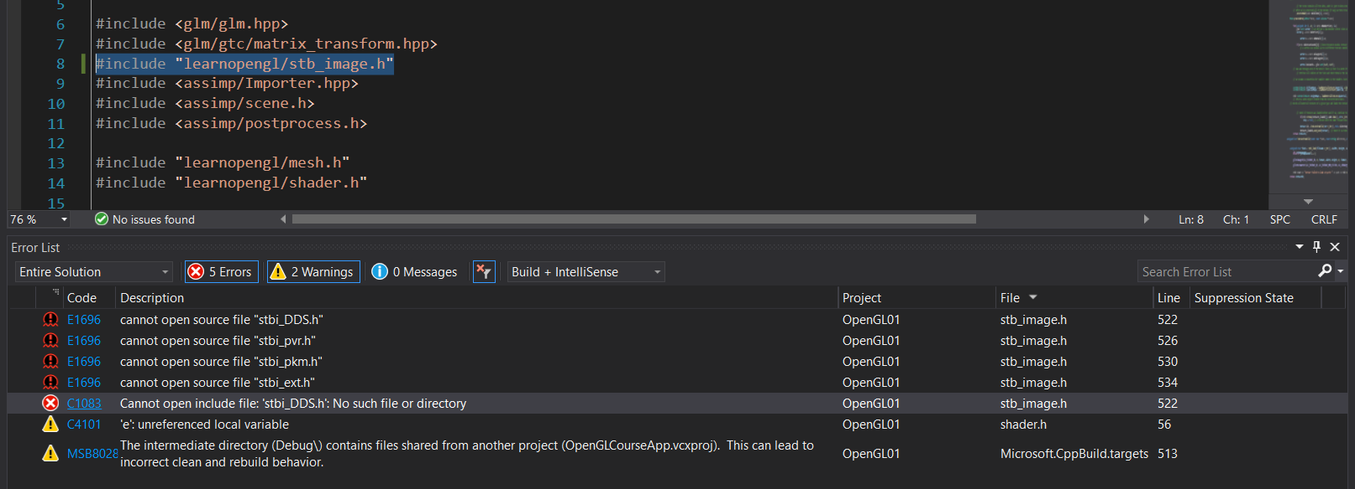

这个是在关联的stb_image.h文件中的关联文件。

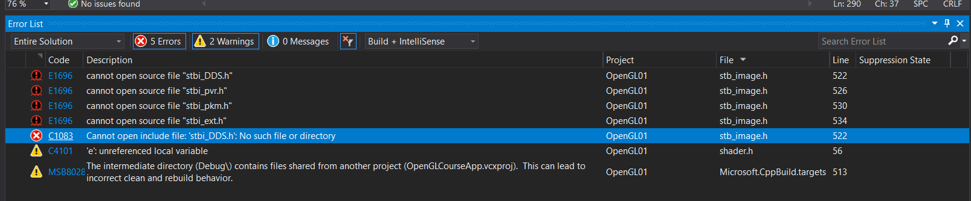

现在将这些文件整体复制到learnopengl文件夹中。

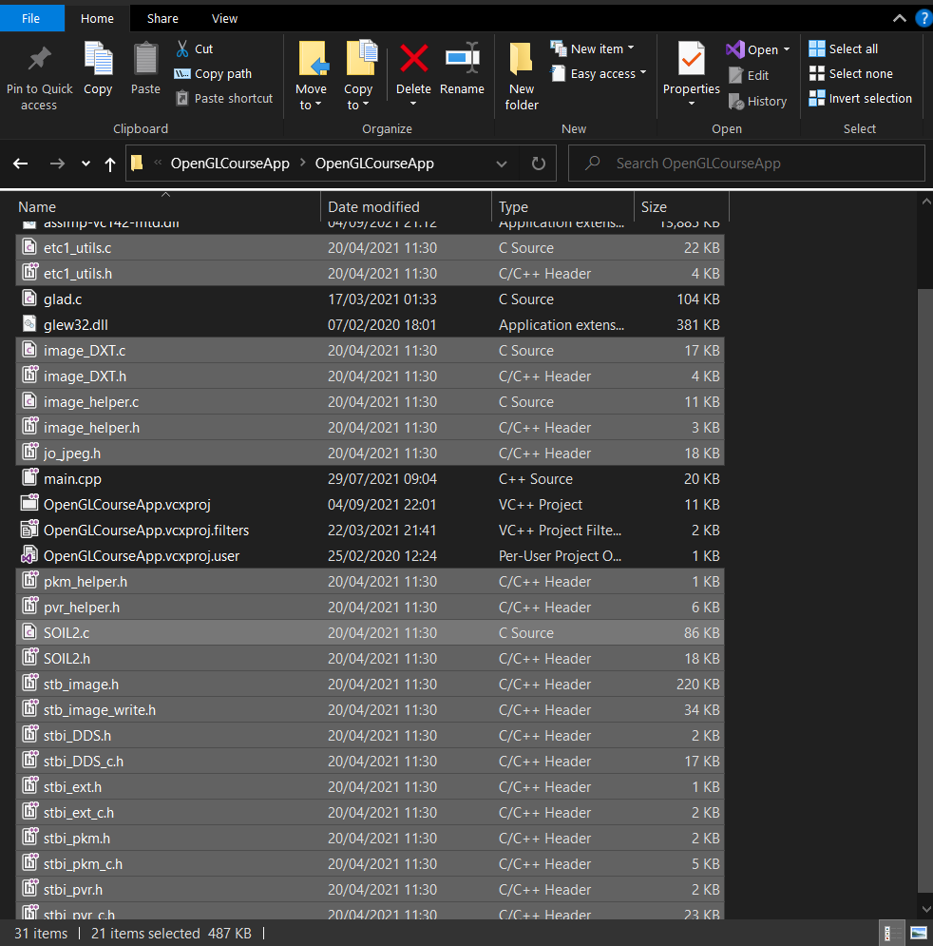

不能复制到learnopengl，改复制到了main.cpp所在目录

还是不行，现在重新弄到learnopengl目录，并将后面红线手动改成learnopengl/…

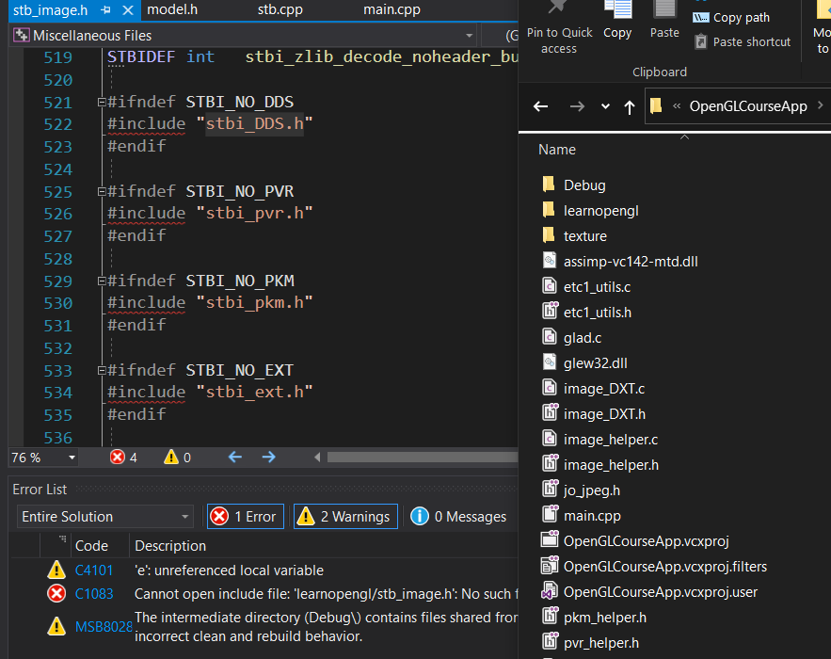

复制成功。

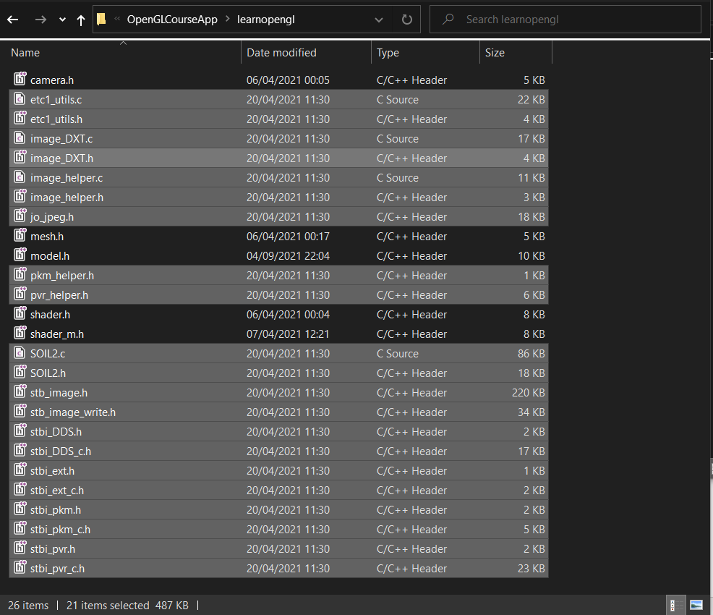

还是不行，或上网查教程。

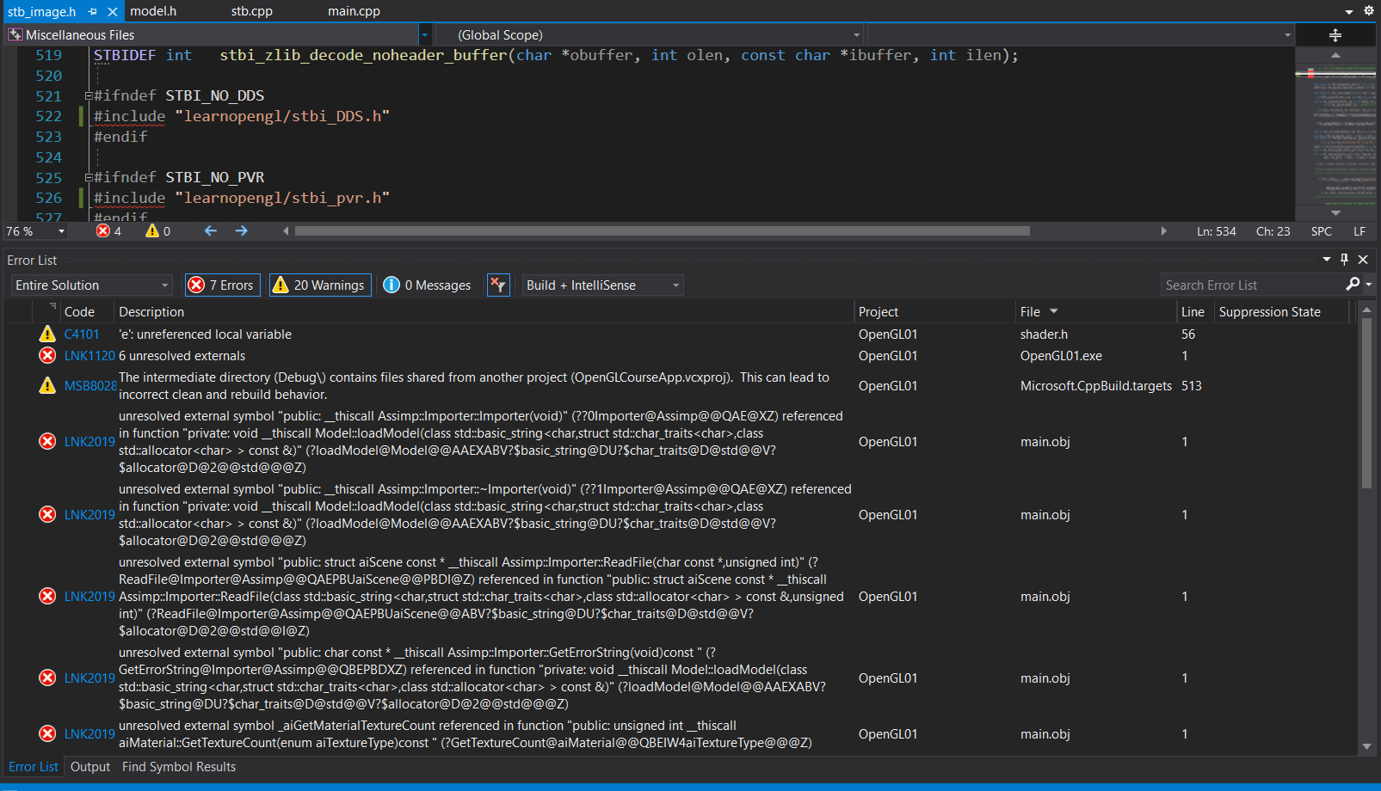

[C++ OpenGL Tutorial - 6 - stb_image Installation - YouTube](https://www.youtube.com/watch?v=Z4I_EEskNK4)

找到了一个教程。

这里换了，原来是texture/…

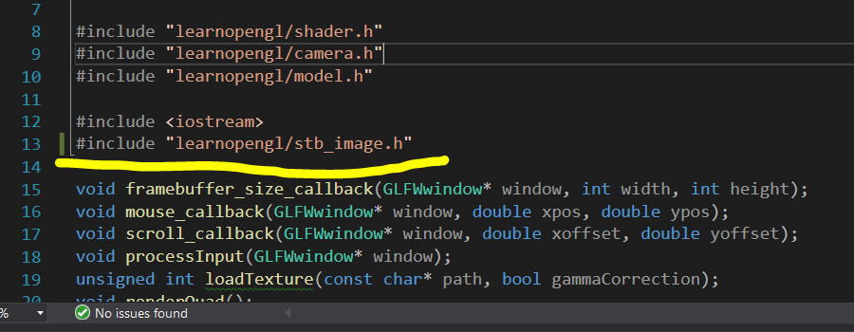

现在要跟这个教程。

[OpenGL LearnOpenGL Using stb image h to Load a Texture Visual Studio 2017 - YouTube](https://www.youtube.com/watch?v=fdn1y5Yq424)

添加了一行代码，然而还是有误。

#define STB_IMAGE_IMPLEMENTATION

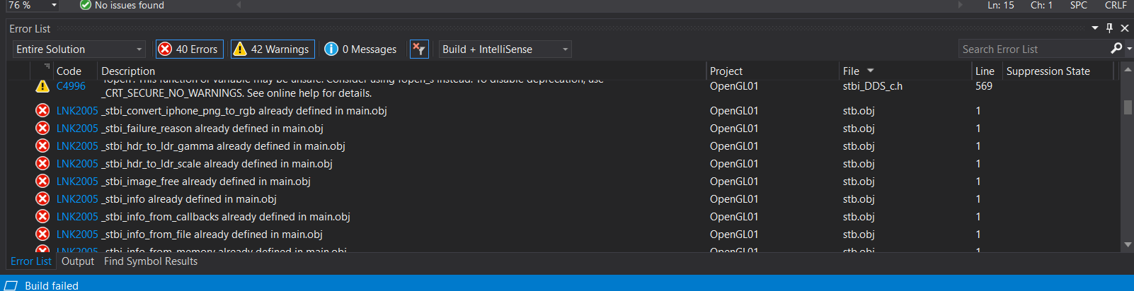

[Code Viewer. Source code: shaders/advanced-lighting/deferred_final (learnopengl.com)](https://learnopengl.com/code_viewer.php?code=advanced-lighting/deferred_final&type=fragment)

或仅用更换片段着色器。

继续渲染

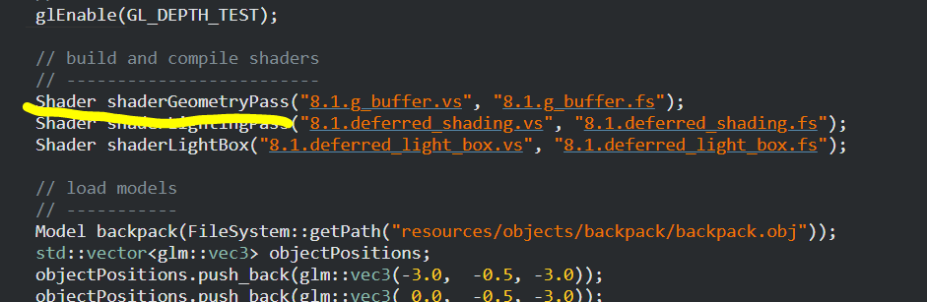

教程着色器代码为此

将此处的代码带入27.2-13后，可以运行，但是是黑屏。

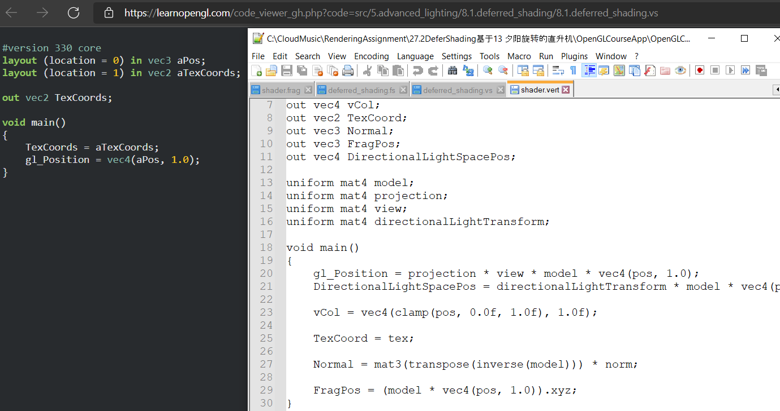

对比顶点着色器，暂时跳过，后或试逐一加代码与Udemy shader中。

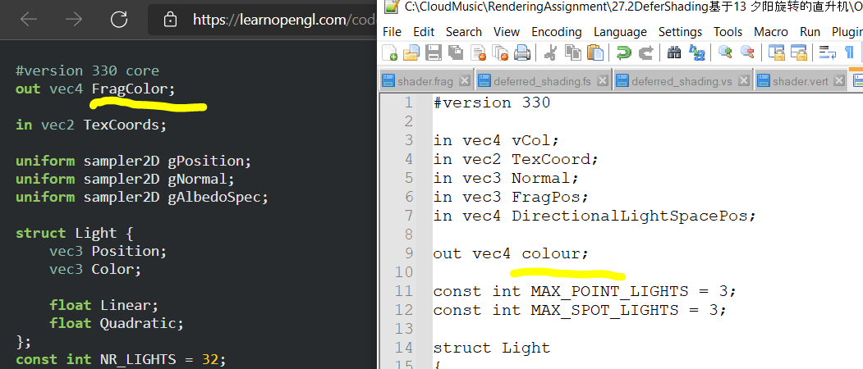

LearnOpenGL教程中 FragColor 即为我方colour.

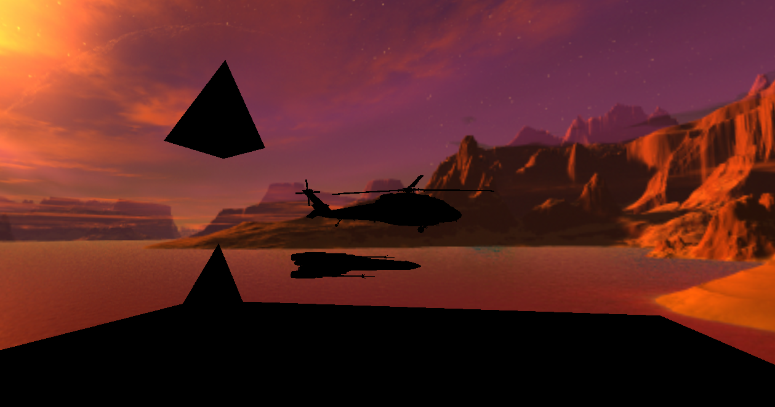

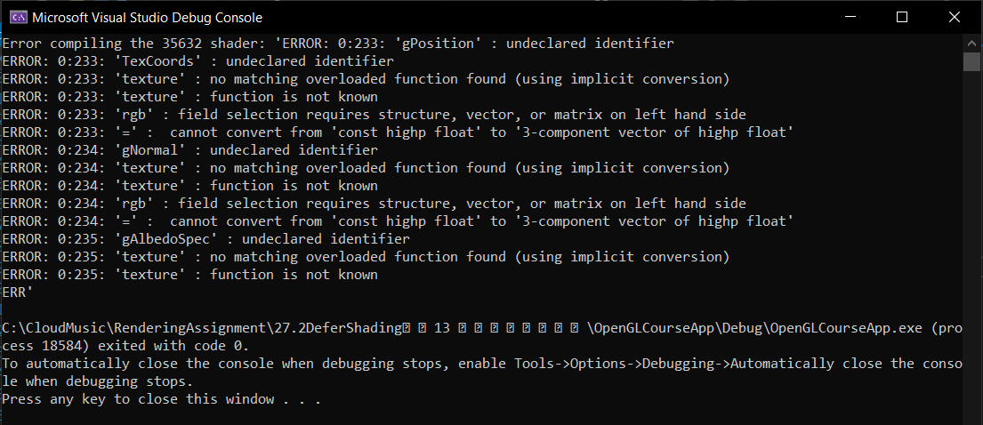

27.2全部为黑色，后或调好。

找到了，14.5即为之前渲染的作业五，现在创建了27.3基于14.5工程。

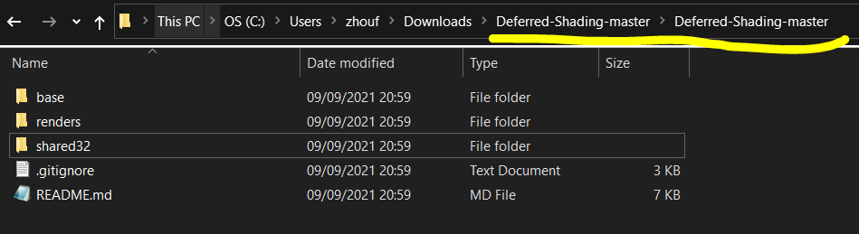

现在下载了这个工程，找sln文件

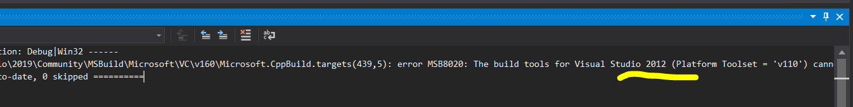

显示需要下载2012年的版本。



在此下载。

[Visual Studio Older Downloads - 2017, 2015 & Previous Versions (microsoft.com)](https://visualstudio.microsoft.com/vs/older-downloads/)

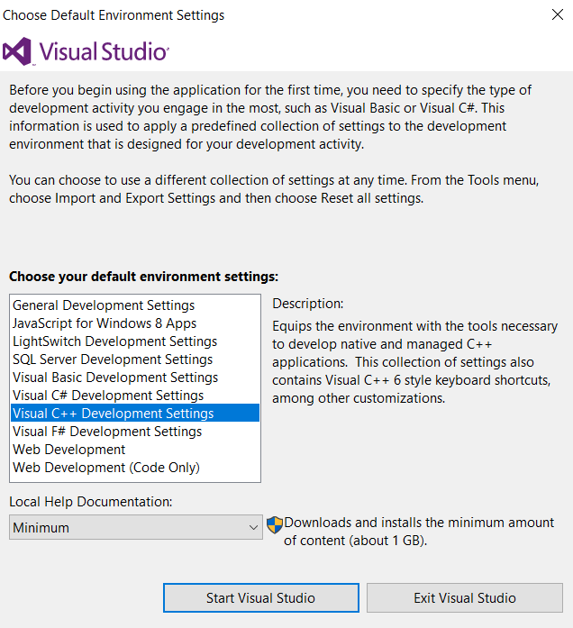  
此处的安装设置选择了C++

安装好了VS 2012, 若占硬盘，后或可删除。

2012版本下载后还是无法找到正确的打开那个github工程的文件。

[OpenGL - deferred rendering - YouTube](https://www.youtube.com/watch?v=0ckE-CZpXAo)

现在看这个非常有用的教程，看完之后修改代码。

（旋转速度 方向可用1,-1调节）Darshan总结。



小记：之前是忘记加上面这个目录文件了，所以未能成功读取着色器文件，现在可以了。

09点57分 2021年9月10日星期五

早起三明

现在精读 <https://youtu.be/0ckE-CZpXAo> 这个教程。

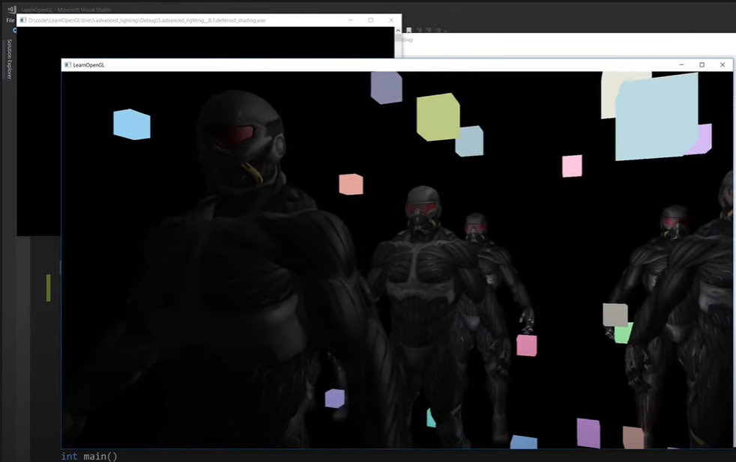

What we have been doing traditionally(so far) is called forward rendering.

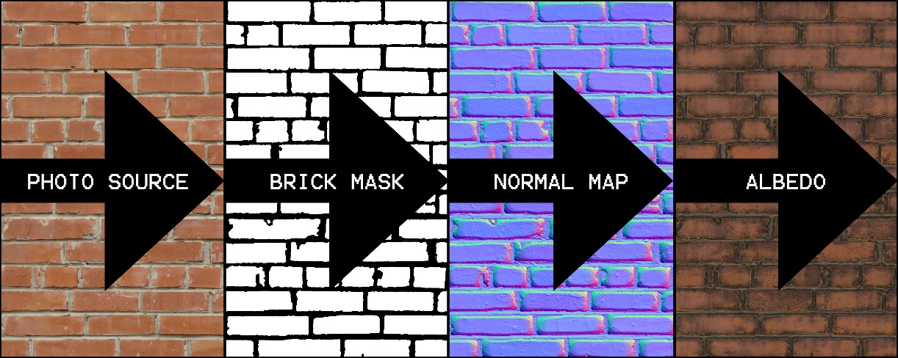

([Making a Tileable Brick Wall (without sculpting) - Melting Logic](http://blog.meltinglogic.com/2015/04/tileable-without-sculpting-brick-wall/))

Deferred rendering is the primary alternative, difference-> for each pixel all the information needed to compute its lighting we first render that information into off-screen buffers, and only once our geometry is rendered into these

G Buffers(Geometry Buffers), only then do we combine them all in a rendering pass that does the actual lighting calculations.

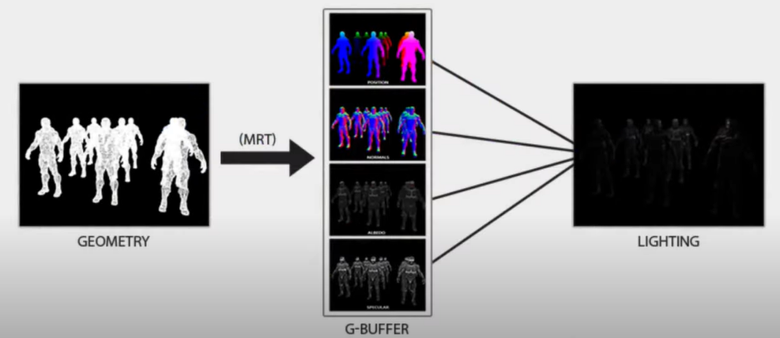

Like a post-processing effect the lighting phase just renders onto a quad encompassing the whole screen. And it samples all the information it needs to do the lighting per pixel from the G Buffer.

Now, be clear that we can visualize the G buffers, because they do store RGB values but aside from the albedo buffer which sorts the diffuse texture information. The data in these buffers is not really color data, the positions and normals are XYZ value. It’s usually in terms of world space. And the specular value is usually a monochromatic value specifying the specular lighting strength to apply to each pixel.

Deferred rendering does not substantially cost memory space and bandwidth for the buffers, but it can drastically improve the performance of the lighting calculations, for scenes where there are more than a few lights.

Firstly, in the term of overdraw, where multiple polygons overlap for a given pixel. In forward rendering, it is ended up doing the lighting calculations for all of those overlapped pixels even though only the one on top is going to actually show up on-screen. While in deferred rendering, it should be waited for lighting calculation until the pixel, which is going to be on the top is known. This work is not wasted.

However, there are also techniques with deferred lighting that avoids doing the lighting calculation on pixels that are far enough away from the light that the amount of light contributed is unimportant. For a given pixel, ideally only the lighting calculation is performed for those lights that are in range of the geometric position of that pixel.

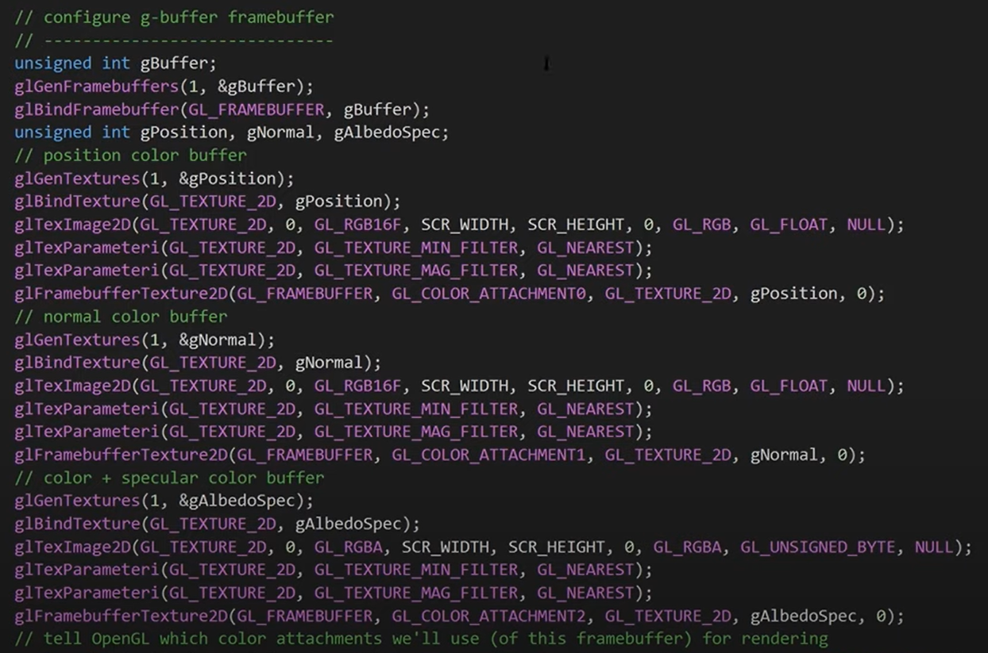

As above code, G buffer should be added, the color attachments for the positions, normals, albedo specular should be added respectively. Since the specular information is merely a single value. The texture and alpha channel was given. The specular was stored in the alpha channel.

Be aware that the normal end position buffers are RGB 16f, 16 bit float point rather than the stock RBG( i.e. GL_RGB16F) on the code. Since the values claimed into the range between 0 to 1 are not wanted. Moreover, 16 bits per channel rather than 8 is expected. Therefore, the precision got accurate.

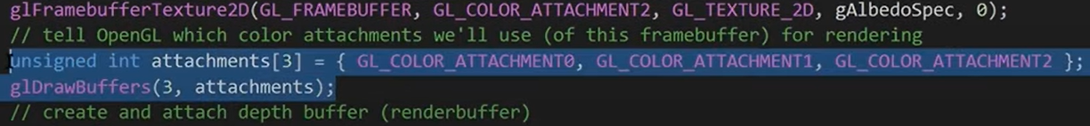

Above are the color attachments, and the glDrawBuffers should be ensured to be specified. There would be 3 color attachments instead of only the default one. As usual, a render buffer was then set up for the depth. That’s all required for G buffer.

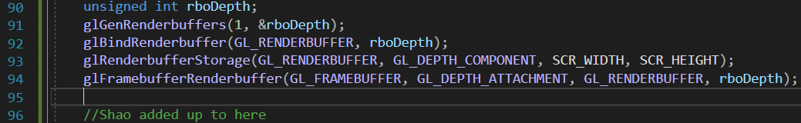

Next, in the render loop, the G buffer should be rendered firstly.

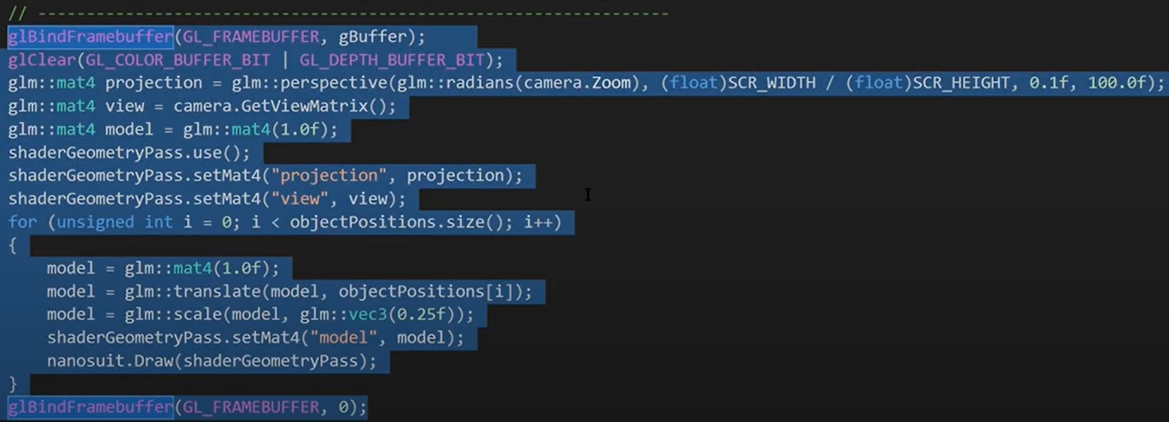

The vertex shader remains the same as previous.

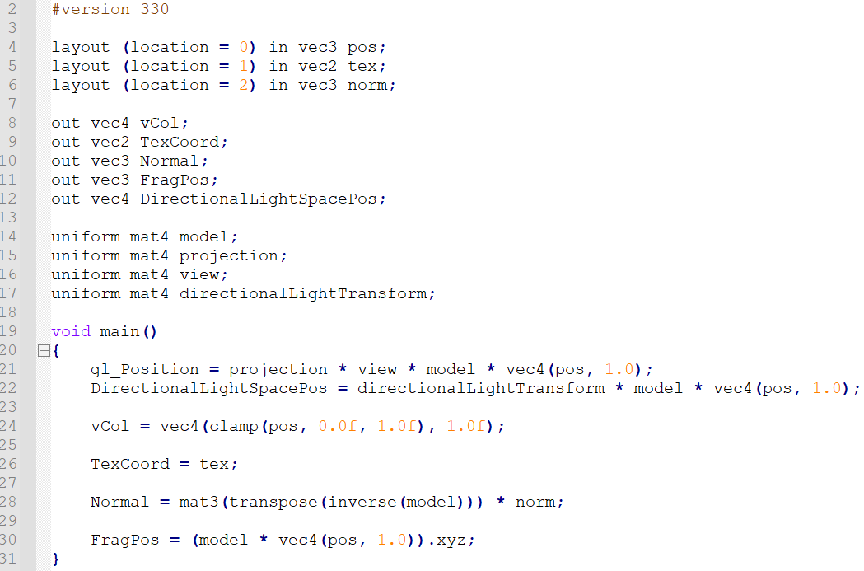

However, in the fragment shader, as below, there should be gPosition, gNormal and gAlbedoSpec. Where the gPosition simply stores the fragment position that got from vertex shader, gNormal stores the normal that got from the vertex shader to an open normalized, and the RGB of the AlbedoSpec, which is the diffuse texture value read from the diffuse map and alpha channel, as mentioned previously, stores a specular value read from the specular map. Besides, the interpolation process may give a non-unit vector.

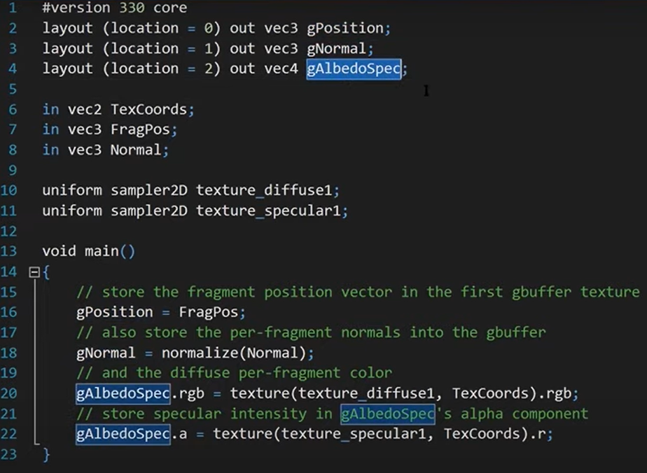

Now, everything required for the G buffer is configurated. The next is for lighting pass, it would be sampled from the 3 color attachments of the G buffer. All the information needed for the lights and the camera. Then, a quad was rendered for encompasses the entire screen, which is identical to a post-processing effect. The vertex shader for deferred shading also remains the same as previous.

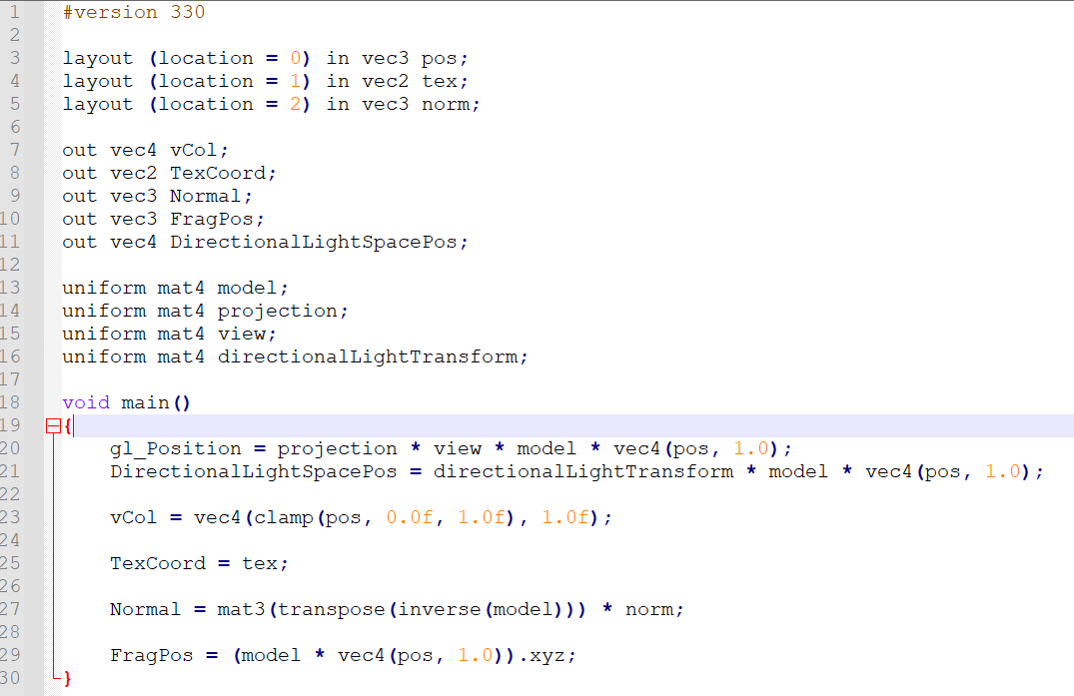

In the deferred shading fragment shader, the lighting calculation is the similar as the lighting in the general rendering projects. However, normal, diffuse, and specular in the Fragment Position are sampled from textures. More importantly, in below shader code, for every pixel, the full lighting calculation for every single light is implemented. Some extra lighting work in cases of overdraw were substantially utilized. But there were still many unnecessary calculations for may pixels. Since the diffuse and specular values were basically 0 for lights that are far away.

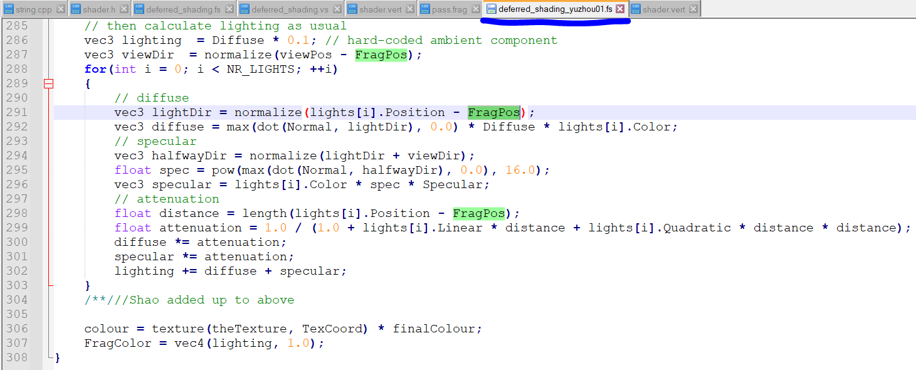

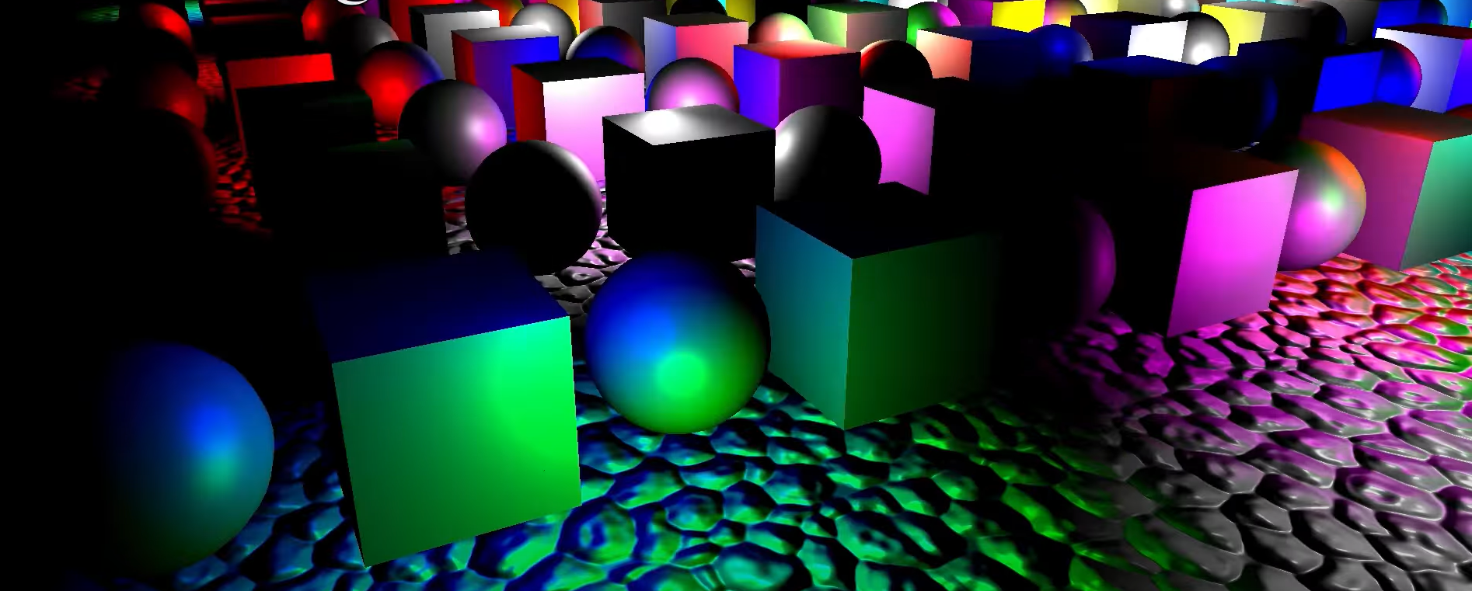

There are cubes and spheres were implemented for demonstrating deferred rendering. Those colored objects were rendered afterwards with forward rendering. The color lighting and the textures were rendered using different shaders. This is an obvious disadvantage of the deferred rendering.

In the lighting pass, just one shader was used to draw everything, therefore the texture of the cubes and spheres were not visible in above example, i.e. the solid object could not be implemented here.

Another limitation is that, the transparent surfaces are not able to implemented in deferred rendering because that requires drawing back to front and blending with each layer. In deferred shading, developers cannot do any blending.

Consequently, the solution to these issues are utilizing forward rendering pass on the top of the deferred shading, that’s what for the next step below.

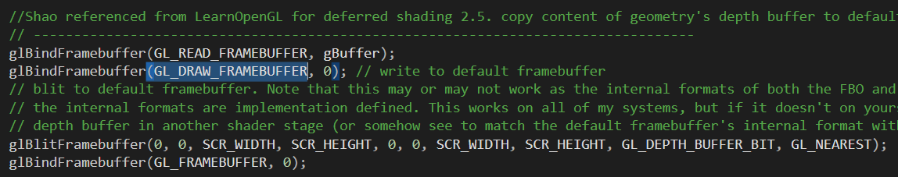

Copying the G buffer utilized above logic. GL_DEPTH_BUFFER_BIT and GL_NEAREST should be specified. The nearest neighbor filtering, instead of bilinear, is required. Therefore, the depth information is copied into the default frame buffer.

After that the forward rendering is implemented as below, using the different shaders.

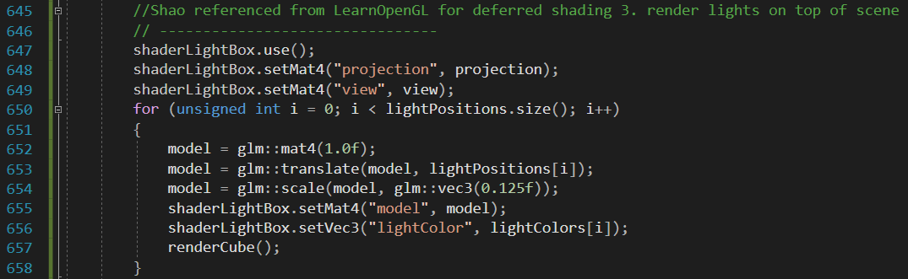

In case of cutting down the lighting calculation work consuming, computing a max radius for every light, beyond which has no effect, is one of the easy solution. Regularly, the radius is based on the color of the light and calculate the distance at which that light attenuates just some minimum threshold color, and consider the cut off distance.

However, while implementing the lighting calculation for every pixel, whether the world position of the fragment is greater than the max radius distance of the light can be simply checked. If so, the lighting calculation can be skipped.

Unfortunately, this easy solution dose not provide the optimal benefits. Since many cores, especially 64, in the GPU, all executing the same path through code such that for an if statement in code. Only if the condition is false for every single core is the branch skipped over. If the condition is true for even merely one core, then for other cores whose condition was false basically have to sit and wait while the other cores processing in that branch.

Therefore, with the solution, for may pixels in many cases effectively provides the computation work for lights(even it is not within the distance of the radius). It is feasible for the optimal case that all the cores are processing pixels that happen to be outside the radius, so the computation for those pixels for that light is skipped. In this case, the solution may provides some advantages but it is beyond the optimal.

Consequently, one method for reducing the wasted lighting work is to compute a bounding sphere for each of the point lights rather. Instead of rendering to a full-screen quad, the spheres can be rendered. However, while a sphere is rendered, only the calculations for the light, associated with the sphere rather than any of other lights, is processed. And it is necessary to ensure that the blending mode is additive so that while a pixel is being rendered on to multiple spheres the diffuse and specular lighting calculations accumulate and then as allows pass we apply the RB factor for the full screen quad. With the help of this technique, back faces should be ensured to coded.

Otherwise, for each light each pixels would be rendering twice. The problem that arise though for the conditions when the camera is positioned inside a sphere which can happen depending upon the position and radius of a light. In that condition that back faces are coded, the light is not able to be rendered at all. There is one solution for solving this defect involving the stencil buffer.

However, an alternative method called tiling works for this issue. The general idea of it is very straightforward. The screen space up into tiles can be split. Furthermore, the bounding boxes, of all the lights in terms of screen space, should be also computed. For each tile, which light bounding boxes overlap that tile should be verified. And that is a set of lights used for the pixels of the specific tile. The light of the tile, the more light bounding boxes intersecting the tile.

Therefore, with the tile based light becomes more practical on modern hardware to render not merely a handful of lights but several hundreds even into the low thousands. It is necessary to remember that deferred rendering also causes significant costs in case of memory usage and bandwidth and so it’s generally still not appropriate for lower end hardware particularly in the mobile phone. Even on high-tier hardware, if it is not going for a realistic rendering performance, forward rendering is still preferable. It should be cleared that it mainly handles the use of lights rather than the aesthetic over watch for example is with a cartoony adorable appearance, while deferred rendering is still utilized.



重要，此处需要加在main.cpp上。

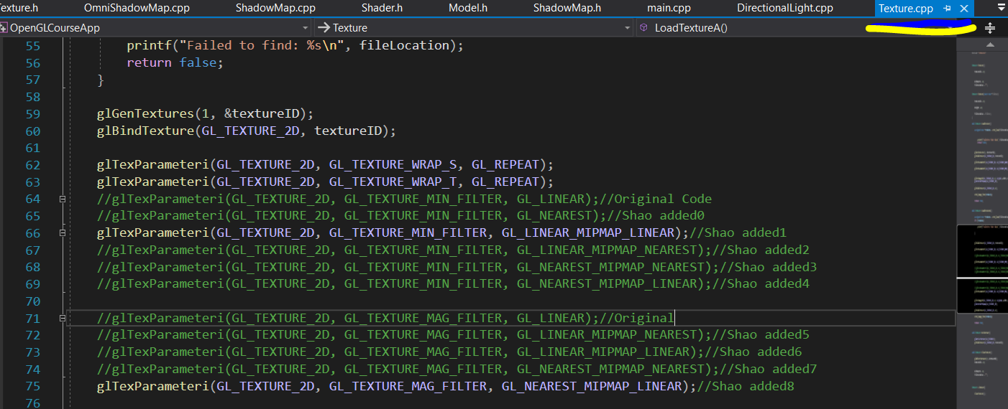

或我方texture.cpp，而非main.cpp

//Shao added below for deferred shading

glGenFramebuffers(1, &gBuffer);

glBindFramebuffer(GL_FRAMEBUFFER, gBuffer);

//Shao added up to here

我方：一样的之前错误报告。

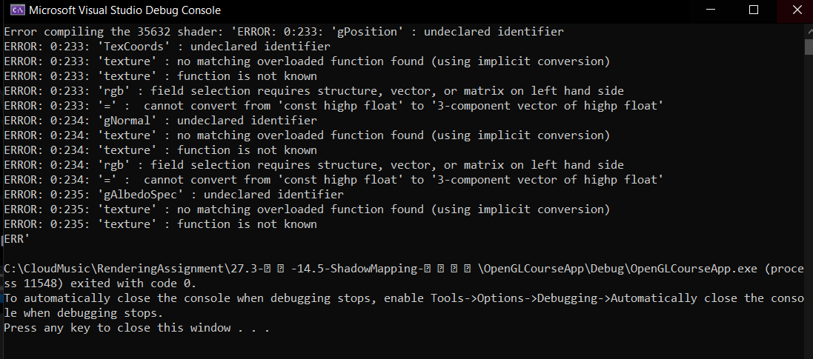

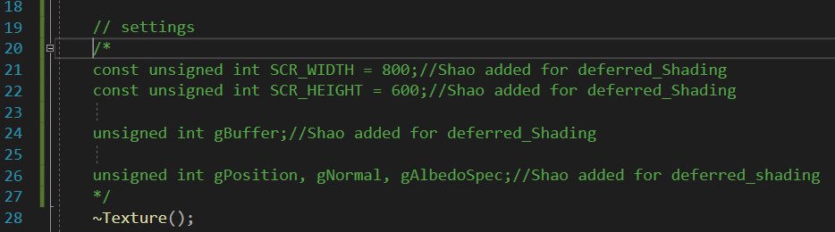

Texture.h 中的这段代码导致报错。

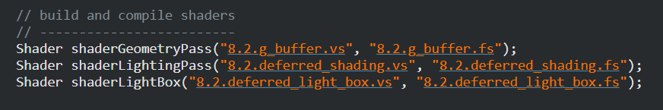

教程中有6个着色器，或与我方不一样，以下为我方，都差不多。

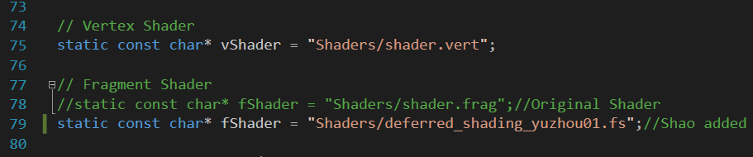 左边为最佳需要调整的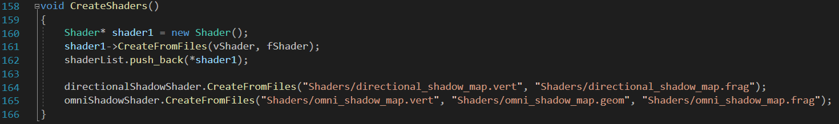

第二行肯定是要找的Shader, 第一行不确定要不要加上。

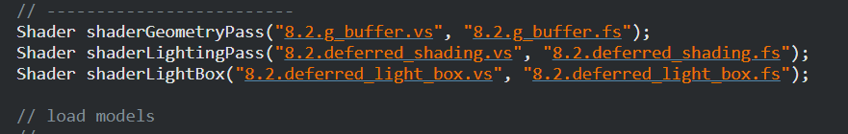

[Code Viewer. Source code: src/5.advanced_lighting/8.2.deferred_shading_volumes/8.2.deferred_shading.fs (learnopengl.com)](https://learnopengl.com/code_viewer_gh.php?code=src/5.advanced_lighting/8.2.deferred_shading_volumes/8.2.deferred_shading.fs)

现在对比此片段着色器与我方着色器。

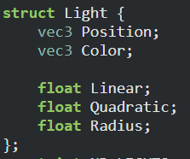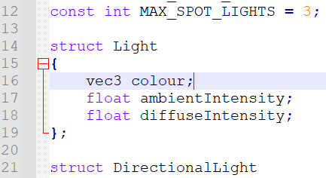

现在对比上左教程代码，将此插入我方上右。

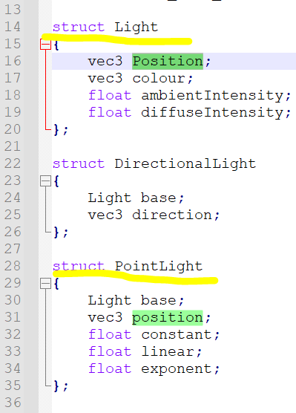 这两struct 或有重复，以上面的这个为主，有隐患，若后冲突，回看。  
有两个Positions, 为了避免冲突，我方加入了大小写以区别。

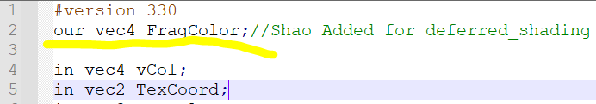

加入了Out 整个就会变黑，因为主函数中未改写。

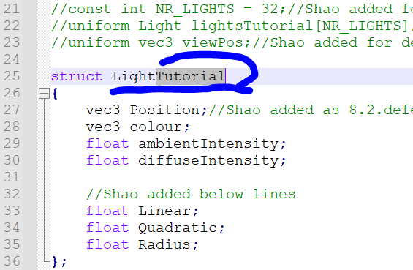

Tutorial要在此删掉，不然会变黑。

现在创立一个新建的struct, 命名为LightTutorial

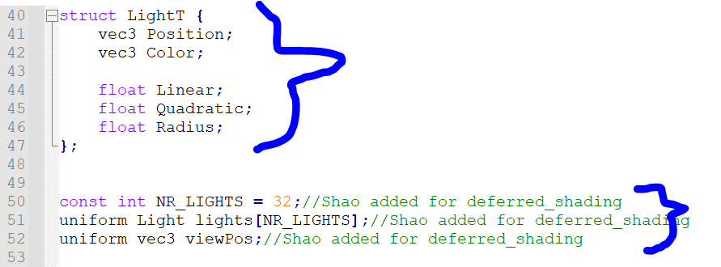

这两段的顺序不能反了。



为了避免冲突，我方line37 将原来的Light 改成了LightT ,后面的主函数中需要对应地调整。

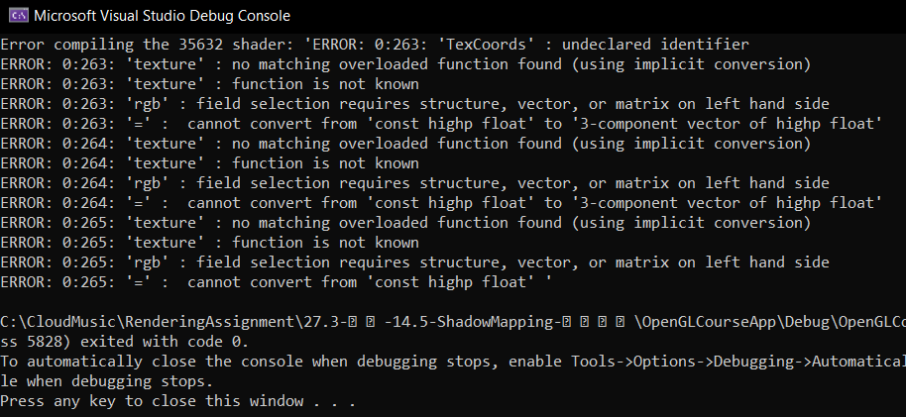

黑色图形，错误报告如上。

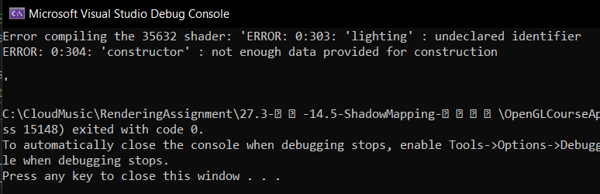

现测试能否使用两个out ，出现上述报错，或由于主函数大量代码注释掉了所引起。

现在先调整注释掉了的代码，若不行就消掉一个out, 注释掉原来的shadow mapping，仅保留现在做的defer

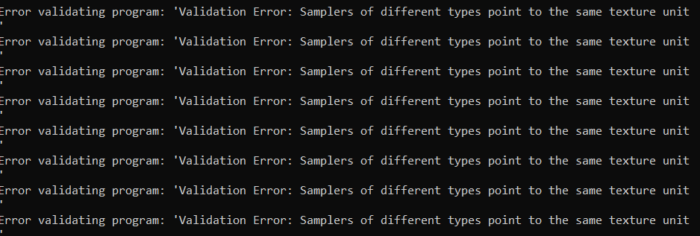

两个out 同时存在，则出现了这个错误。

一个out 也是这样，Samplers of different types point to the same texture unit

在此将之前的Light 改成LightT, 若不行就接着看教程。

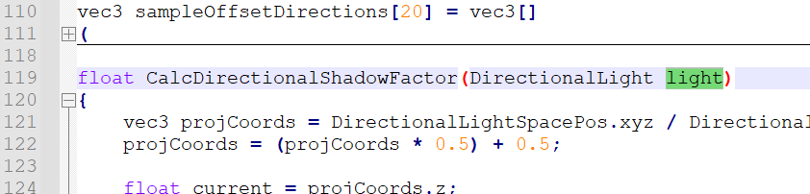

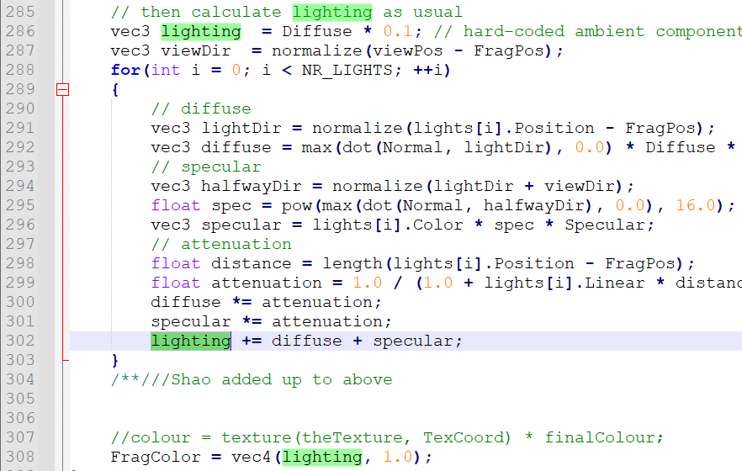

初步对比发现，教程多为lighting 或Lights, 而我方原有的shader中多为light，暂时没有发现有冲突。

那么问题应该是在texture上

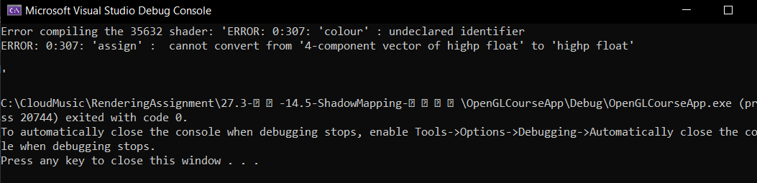

新的报错。

维基参考

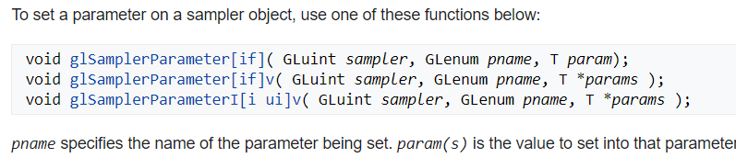

08点02分 2021年9月12日星期日

运行后是黑影，然后显示这个。

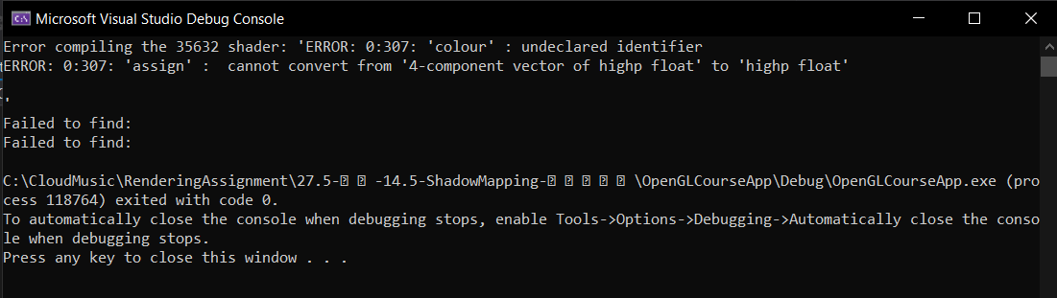

JP Morgan

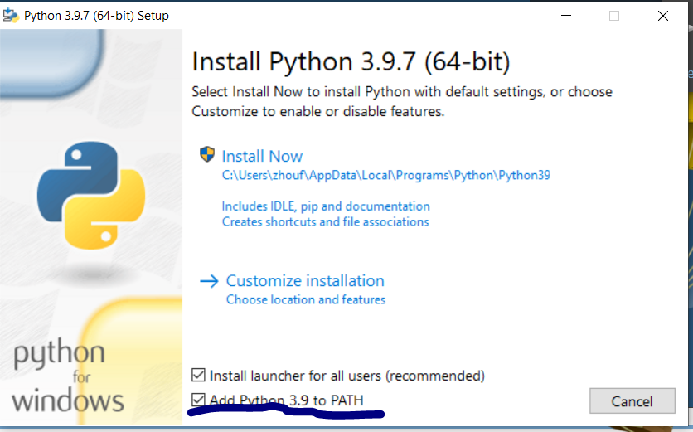

Python Path